Geometry: Unit 7, Lesson H2
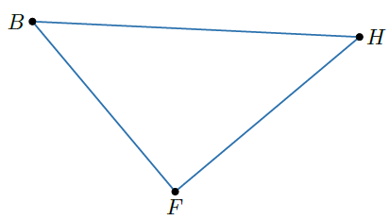
- Triangle $HFB$ is shown where $m∠BHF=43°$, $m∠HFB=90°$, $BH=x$, $BF=12$, and $FH=13$. Write an equation that can be used to determine $x$.

$$\sin\left(43°\right)=\frac{12}{x}$$

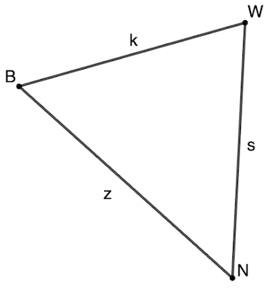

- Triangle $BWN$ is shown. What side corresponds to angle $∠WNB$?

Side $k$
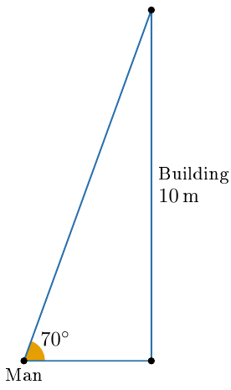
- A man is standing near a $10$-meter tall building and looking to the top of the roof at a $70°$ angle as shown. How many meters away is the man from the building?

$3.64$ meters

